Covid19 PREDICTION with deep LEANRING ON NEURAL NETWORKS

Manideep Baddam 700742009 Kanneganti Venkata Siva Sai 700756408
Sushma Alampally 700743513 Sampath Kumar Chittepu 700757946

Abstract:
Rapid spread of Coronavirus disease COVID-19 leads to severe pneumonia, and it is estimated to create a high impact on the healthcare system. An urgent need for early diagnosis is required for precise treatment, which in turn reduces the pressure in the health care system. Some of the standard image diagnosis available is Computed Tomography (CT) scan and Chest X-Ray (CXR). Even though a CT scan is considered a gold standard in diagnosis, CXR is most widely used due to widespread, faster, and cheaper. This study aims to provide a solution for identifying pneumonia due to COVID-19 and healthy lungs (normal person) using CXR images. One of the remarkable methods used for extracting a high dimensional feature from medical images is the Deep learning method. In this research, the state-of-the-art techniques used is Genetic Deep Learning Convolutional Neural Network (GDCNN). It is trained from the scratch for extracting features for classifying them between COVID-19 and normal images. A dataset consisting of more than 5000 CXR image samples is used for classifying pneumonia, normal and other pneumonia diseases. Training a GDCNN from scratch proves that, the proposed method performs better compared to other transfer learning techniques. Classification accuracy of 98.84%, the precision of 93%, the sensitivity of 100%, and specificity of 97.0% in COVID-19 prediction is achieved. Top classification accuracy obtained in this research reveals the best nominal rate in the identification of COVID-19 disease prediction in an unbalanced environment. The novel model proposed for classification proves to be better than the existing models such as ReseNet18, ReseNet50, Squeezenet, DenseNet-121, and Visual Geometry Group (VGG16).
Key Words: Genetic Deep Learning Convolutional Neural Network (GDCNN), Computed Tomography (CT), Chest X-Ray (CXR), Artificial Intelligence (AI)

Introduction
The official term for the novel coronavirus is severe acute respiratory syndrome. Coronavirus Disease 2019 (COVID-19) is caused by coronavirus-2 (SARS-COV-2) [1]. A few COVID-19 symptoms include fever, coughing, respiratory system illness, and in rare circumstances, pneumonia [2]. Pneumonia is commonly described as the infection that inflames the lung's oxygen-transferable air sacs. Pneumonia can also be contracted by various viruses, bacteria, and fungus. The severity is caused by aged individuals, smoking, immune system impairment or weakness, and chronic conditions like asthma or bronchitis.
The infected peoples are treated based on the infected organism, however, cough medicine, pain reliever, fever reducer, and antibiotics are given to patients based on the symptoms. If the patient is severely affected, they have to be hospitalized and treatment must be given in the Intensive Care Unit (ICU), if needed ventilator to be provided for breathing [3]. The pandemic of COVID-19 is due to its seriousness and its faster transmissibility [4]. Greater impact in the health care department is mainly due to the number of people getting affected day by day, as they need to provide mechanical ventilator for the serious patient admitted in ICU. Hence, number of beds in ICU also need to be increased drastically [5]. In the above situation, the initial diagnosis is vital for proper treatment which, in turn, reduces the pressure on the health care system.
A significant advancement in the detection of COVID-19 and other pneumococcal diseases has been made possible using artificial intelligence (AI). Certain common imaging tests, such as a chest X-ray (CXR) and computed tomography (CT) scan, are used to detect pneumonia. CXR is the main resource used to evaluate pneumonia since it can result in inaccurate and imprecise diagnoses. Nonetheless, CXR is employed due to its lower cost, quicker recovery time, reduced radiation exposure for patients, and widespread availability across all healthcare systems [6]. It is difficult to diagnose pneumonia since the examiner must examine the white patches in the lungs and the majority of the water- or pus-filled air sacs. Consequently, the procedure of differentiating is laborious between TB and bronchitis [7].

Ease of Use

PANDEMIC AND PNEUMONIA DISEASE COVID-19 The first COVID-19 case was reported in Wuhan, China, and it is gradually starting to spread across the rest of the world within a short interval of time. This indicates that the number of cases reported increases exponentially, as of now more than 8.24 million confirmed cases worldwide [1]. COVID-19 Epidemiological characteristics are still under the process of investigation, evidence prove that more or less, 80% of patients are in mild condition with few asymptomatic and approximately 20% are in severe condition among, this 10% have to be in ICU with ventilators [8]. The most important concern is the number of patients admitted to the ICU as there are only limited beds. The major problem of COVID-19 is pneumonia, as it infects a portion of the lung, which transfers gas termed as pulmonary parenchyma. Some of the organisms like fungi or bacteria and viruses are also present. Generally, pneumonia is termed as a group of diseases, hence diagnosis also needs to be different, therefore, Chest X-Ray image and CT scan used for diagnosis [9]

CLASSIFICATION OF CLASSES
Flat classification involves multi-label, binary, and multi- class classification problems; however, multi-label includes multiple classes, and the output is associated with each other. Binary classification is stated as the task of classify- ing the images from the given dataset into two categories on the basis of classification rules. Some of the methods used for classification are random forests, decision trees, support vector machines, Bayesian networks, probit models, neural networks, and logistic regression. Table 1 shows the parameters explanation in terms of symbol and its explana- tion. The features are represented by ‘x’ containing a set of parameter’’x1,x2‘’ and it is shown in equation (1). The output is represented by ‘y’ as in equation (2), a decision function based on the weight for each parameter is evaluated using equation (3). The algorithm function is represented by equation (4), thus the number of parameters is based on the hierarchy defined on the basis of incomplete order set [10] Moreover, the various ways to handle hierarchical classifica- tion problems in regards to labeling classification process also discussed [11]. Local classifiers (LC) are an approach that considers hierarchy and partial local information perception and thus allowing the multi-class/binary classifiers to handle the problem in a local manner [12], [13]. Furthermore, the Global Classifier (GC) approach is a unique classification model built based on the training dataset. Considering class hierarchal as a whole, thus significant information on the pneumonia labels is found in the entire class hierarchy, thus, GC approached is widely used [14], [15].
Multi-class classification output is given by ‘y’ using equation (7), the number of parameters is stated by the equa- tion (9) and classification accuracy using equation (10 ).
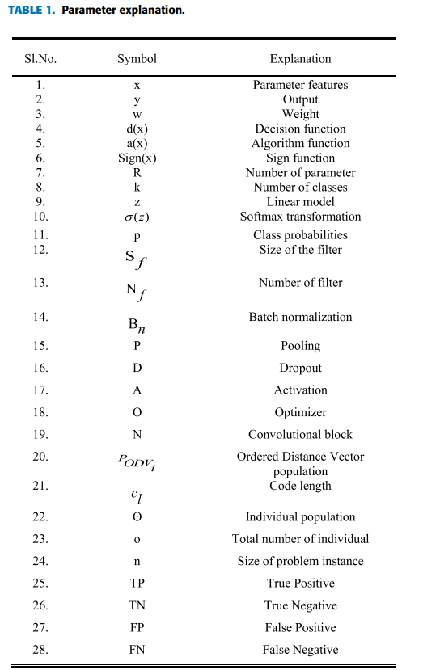
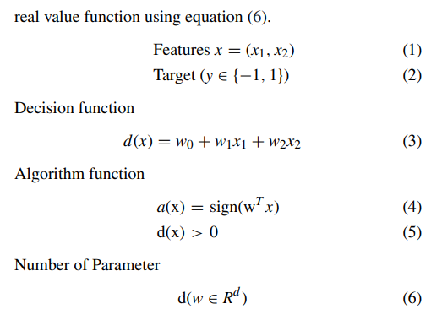
The background information above makes it evident that pneumonia is classified using multiple classes because numerous features must be extracted from CXR images while only one label must be assigned.
According to Silla et al., taxonomy is used to define a tree hierarchy based on an incomplete order set [10].
Also covered [11] are the different approaches to solving hierarchical classification issues with reference to labeling classification processes. Local classifiers (LC) are a method that takes partial local information perception and hierarchy into account, enabling multi-class and binary classifiers to handle the problem locally [12], [13]. Furthermore, a special classification model developed using the training dataset is the Global Classifier (GC) approach. Taking into account the overall class hierarchy, therefore important information
Multi-class classification output is given by ‘y’ using
equation (7), the number of parameters is stated by the equation (9) and classification accuracy using equation (10).
Multi class classification
Section I describes the pandemic situation in the health care system due to COVID-19 and the early reasons for diagnosing it. Section II states the existing techniques used for classification of images and Deep Learning Convolutional Neural Network models used for prediction of COVID-19. Section III depicts the proposed Genetic Deep Learning Convolutional Neural Network comprising of Ordered Distance Vector population techniques for optimal prediction of COVID-19. Section IV represents the experimental analysis of the proposed work, and it is compared with the existing DCNN models. Some of the parameters used for performance analysis are sensitivity, accuracy, specificity, recall, precision and F1-score. Conclusion of the proposed GDCNN models in future works.
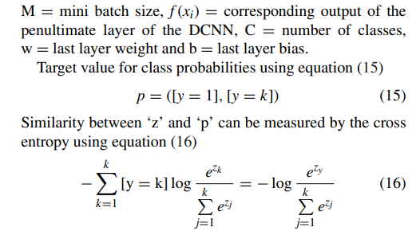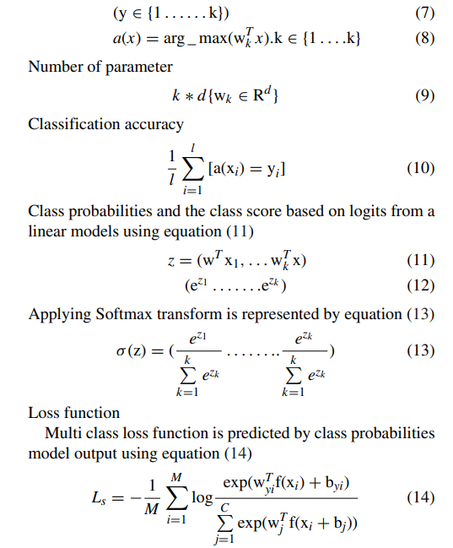
M = mini batch size, f (xi) = corresponding output of the penultimate layer of the DCNN, C = number of classes,
w = last layer weight and b = last layer bias.
Target value for class probabilities using equation (15)
p = ([y = 1], [y = k]) (15)
Similarity between ‘z’ and ‘p’ can be measured by the cross entropy using equation (16)
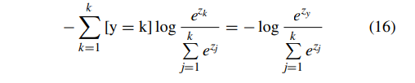

IMBALANCENESS DATA AND RESAMPLING
When working with real datasets, the majority of researchers have encountered issues with class imbalance distribution [16], [17]. Classifier algorithms prioritize reducing the overall error rate, which means they concentrate on majority classes. However, they also pay attention to minority classes that are specific to the problem area, including credit card fraud detection and medical picture classification [18], [19]. Because there are fewer cases of pneumonia than there are healthy individuals, use CXR images to determine the type of pneumonia is seen as unbalanced learning in the actual world [20], [21]. However, there is also an imbalance in the number of individuals afflicted with different forms of pneumonia [22], [23].
MOTIVATION:
The mortality from lung sicknesses can be decreased by means of exact and convenient finding. conclusions and treatment are deferred due to the deficiency of experienced radiologists. The huge irregularity between the quantity of specialists and the number of inhabitants in a speciﬁc region likewise thwarts opportune finding. The decision-production of clinical staff can be enhanced by PC supported analytic instruments, which join parts of PC vision and deep learning with radiological picture examination to perceive and remove designs.
OBJECTIVE:
The objective of Covid19 disease prediction is to predict the Covid19 from the chest x-ray images. Set of x-ray images of patients with Covid19 is taken for the training and x-ray images of test images also taken and finally the results are predicted.

FEATURE:
Covid19 is a respiratory contamination brought about by microbes, infections, or parasites, and it has been known as a very normal and possibly lethal illness in the beyond two centuries. Inspired by the finding system of human specialists, we join the clinical perception with the clinical pictures. propose a requirement based calculation that consolidates clinical information to fabricate a sensible convolutional neural networks.

Related Work
A thorough analysis of the many methods for classifying photos is done. Additionally, the current CNN models that are used to predict COVID-19 using CT and CXR images were discussed. The accuracy of the analysis is given for a range of prediction models. A thorough analysis is conducted on the automation of DCNN architecture for image classification and search.
A deep learning model was proposed by Zhou et al. in 2020 [46] to differentiate between novel coronavirus pneumonia and influenza pneumonia based on CT images. Although CT scans are more expensive than CXR images, they are superior because they clearly depict pulmonary infection. Li et al. [47] used artificial intelligence (AI) to identify COVID-19, resulting in a dataset that included patients with pneumonia diagnoses, different types of pneumonia, and afflicted COVID-19 images. The images are gathered from Chinese hospitals containing 2969 images of the training set, viral pneumonia 1396, more than 400 images of COVID-19 patients, and 1173 non-pneumonia. The 3D learning model for the prediction of COVID-19, non-pneumonia, and different viral pneumonias is given as input, according to K. He, X. Zhang, et al. in 2016 [34]. The prediction's output unambiguously demonstrates that the AUROC value for COVID-19 is 0.96 and the AUROC value for other viral pneumonia is 0.95.
In 2020 [48], Narin et al. used CXR images and three distinct deep neural networks—Inception-V3, ResNet50, and InceptionResNetV2—to detect COVID-19. There are 50 COVID-19 positive images and 50 COVID-19 negative images in the dataset, which is made up of 100 CXR images. A fivefold cross is used to validate the result; 87% accuracy is obtained for Inception-ResNetV2, 97% accuracy for Inception-V3, and 98% accuracy with the ResNet50 model. Gozes et al. used deep learning models with CT scans as an input to identify the COVID-19 in 2020 [49]. With the aid of 3D volume, the evolution is carried out for patients, resulting in corneal score. The primary objective of this work is to monitor the COVID-19 pandemic. The dataset comprises 157 CT images that were gathered from China and the United States. Moreover, detection has been done with both 2D and 3D deep learning models, linked to clinical comprehension and requiring minimal modifications to the AI models that are currently in place. 0.996 AUROC distinguishing between non-corona and corneal images.
COVID-Net is an open-source deep neural network designed by Wang et al. in 2020 [50] that is used to detect COVID-19 using CXR images. The dataset, which includes 16,756 patients, was constructed to facilitate COVID-Net experimentation. The COVID-Net architecture was created by combining network architecture with human-driven design and best practices. The detection rate is 80%, the sensitivity rate is 95%, and the accuracy is 92.4%. In 2020, Khan et al. [51] created a CoroNet, a Convolutional Neural Network (CNN) for COVID-19 detection, using CXR images as the input. This model is based on Extreme Inception, which has 71 layers of trained images made from the ImageNet dataset. It finds that 284 COVID-19, 327 viral, 310 normal patients, and 330 patients with bacterial infections are all impacted. With average accuracies of 0.93 and 0.87 for F1-scores, the main issue with this method is the dataset that was used—it is not publicly available. Moreover, there is no discussion of the hierarchical classification. A deeper model for the detection of COVID-19 with CXR images was stated by Ozturk et al. in 2020 [52], hence binary and multiclass classification is used. In binary classification, the suggested model achieves an accuracy of 98.08%; in multi-class classification, it achieves 87.02%.

Method
Proposed a continuous, independent learning algorithm for creating a DCNN architecture on its own. The procedure entails splitting the DCNN into multiple weighted fully connected and meta-convolutional blocks. Pooling, convolution, batch normalization, dropout, fully connection, and activation operation are among the operations available in each block. thereby translating the DCNN architecture into an integer code that is common. The population for DCNN architectures is evolved through genetic processes like crossover, mutation, and selection. With the help of the suggested genetic DCNN design, the individual population is growing and developing. Additionally, a suitable DCNN architecture is used for encoding. Using a random function, the population is initialized at random. Additionally, the fitness of each individual is determined by evaluating how well the genetic DCNN encoding performs when applied to particular image detection tasks. Genetic operators like selection, crossover operator, and mutation are used to create a new generation based on the current generation, thereby improvising overall fitness values. Iteratively, the evolution is carried out based on generation by generation until it meets the requirements or for a specific number of generations.

Encoding Scheme
The suggested genetically based DCNN architecture developed according to a chromosomal locus. As a result, chromosomes are separated into the q-arm and p-arm. The term "gene map" refers to the loci known for a particular genome.The loci on a chromosome are observed as the operations that DCNN must perform; consequently, it is evident that all of DCNN's encoding operations are carried out based on gene maps. The five main operations of a convolutional block are, in essence, pooling, normalization, dropout, and activation.
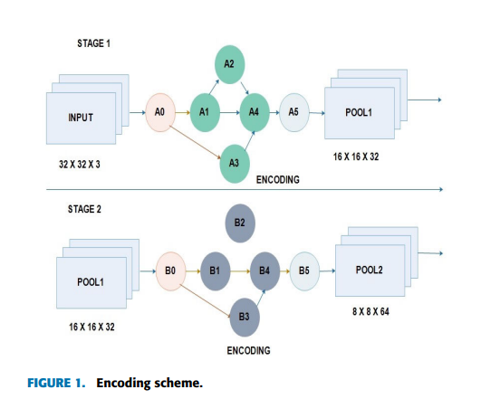
Table 2 shows the range of values at every locus of the code, (Nf ) various from 16 to 512, Sf are 7 × 7, 5 × 5 and 3 × 3, pooling operation is indicated by three values they are 0, 1 and 2. ‘0’ denotes no pooling, ‘1’ state’s maximum pooling and ‘2’ for average pooling. Usually Bn take the value ‘1’ and ‘0’, ‘1’ indicates batch normalization is performed and ‘0’ not performed. ‘A’ various from 0 to 5 stating ELU [2], ReLU [8], PReLU [12], TReLU [18], softmax and LeakyReLU [22]. The value of ‘O’ ranges from 0 to 6 denoting SGD [6], Adadelta [17], Adamax [31], Adam [31], Adagrad [35] and RMSprop [36]. Thus, based on the coding scheme p-arm contains the sequence [Nf Sf Bn PDA] [Nf Sf Bn] and q-arm sequence is [Nf Sf Bn DA].
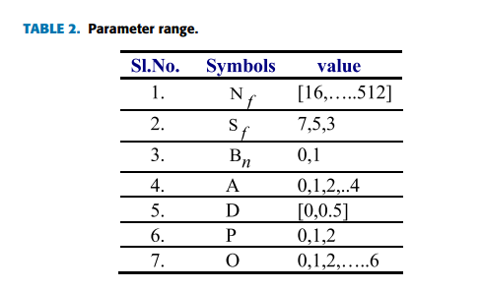

INTIALIZATION
Techniques for Ordered Distance Vector population initialization are employed, encompassing individual variability, stochasticity, and possible order. The use of equation (17) illustrates this. These populations are generated individually, and they have greater individual diversity and more image permutation potential. As a result, it is a better and more efficient solution with a shorter convergence time.

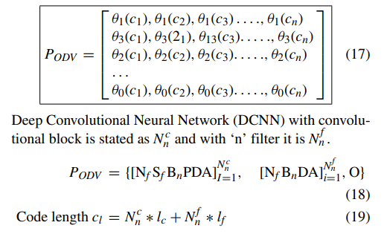

CROSS OVER OPERATOR
A pair of DCNN PODVi and PODVj is selected, thus a point is located randomly to break the DCNN architecture in two segments. Two new DCNN segment is generated by swapping them, that is P 0 ODVi and P 0 ODVj thus the depth is different compared with parents. Let us assume, cross point ‘ki’ is chosen within the ‘cpi’convolutional blocks [Nf Sf BnPDA]cpi on the convolutional arm selected ‘[Nf BnDA]PODVi position is stated as ‘(cpi − 1)∗ lc + x’ similarly, other convolutional arm cpj and its position is stated as (cpj−1)∗lc+x. The code length of the cross operator is given by the equation (20) and (21).

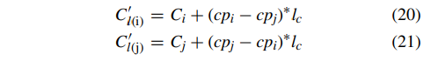
It is clear that ‘8’ learnable layer is needed if the cross point is ‘ki’ is positioned at ‘3lc + 1’ and 11 learnable layers are required at the cross point ‘kj’ positioned at ‘5lc + 1’. Furthermore, after crossover operation the number of layers for DCNN required is 9 and 10 respectively, which is shown in equation (22) and (23),
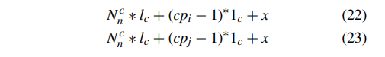

MUTATION
Applying the mutation operator modifies the architecture of the CNN while preserving its diversity across generations. 'qm' is used to accelerate the new DCNN architecture for the population 'PODV' in the interval [8 Ln, 0.5]. After the mutation process is finished, the convolutional block will change (for example, from 5 × 5 to 3 × 3, or from 7 × 7 to 5 × 5). In rare circumstances, the max pooling layer may also be eliminated, and the batch normalization process in the fifth convolutional layer will change from 327 to 513. Additionally, switch from Nadam to RMSprop as your optimizer. Figure 2 depicts the suggested GDCNN designer, which initializes CXR image samples and attempts to enhance the individual population with a permissible encoding scheme.

GENETIC DEEP CONVOLUTION NEURAL NETWORK ALGORITHM
The process involved in the genetic DCNN design architecture is, population initialization where the population is initialized randomly, thereby, it continuously progresses the population on the basis of generation-by-generation for developing better architectures using redefined genetic operations. The Selection operation involves creating a random operation and batch normalization process is performed. Feeding population to convolution neural network activation is processed and maxpooling is performed, train the GDCNN model for achieving fitness value. Furthermore, model fitness is produced using a generator. Selection, Crossover, and mutation activation are performed. The proposed approach is evaluated on two image classification data set for identifying pneumonia, COVID-19, normal and other pneumonia diseases. Our results show that proposed genetic-based DCNN architecture outperforms well and its performance is comparable to the state of the art.

Algorithm
Input: 5000 chest x-ray images (collection of images, training and test data).

Output: Accuracy, sample loss, val _loss,val_acc.
Step1: Initialization Input the 5000 chest x-ray images (training and test data)
Step2: Create random operation
Batch Normalization process
Step3: Feed population to Convolution neural network Activation,
conv2D(512, (3 x 3 ), padding = same, usebias = false) maxpooling (pool size = (3, 3)
Dropout
Step4: Train GDCNN and get its fitness modelfit:generator(datagen.flow(x train, y train, batch size = batch = size),steps per epoch = x train,shape[0](batch size, epoch = epochs,validation data = (x test, y test), callbacks = [plot]) else modelfit:(x train, y train, batch size = batch size, epoch = epochs, validation data = (x test, y test), shuffle = true, callbacks = [plot]
Step 5: selection, crossover, mutation
Activation, conv2D (512, (3 × 3), padding = same, use bias = false) maxpooling (pool size = (3, 3) Dropout
Step 6: New populations train GDCNN and get its fitness Evaluate solution based on fitness value
Step 7: Check optimal solution based of fitness function If (optimal solution == fitness value) Optimal solution obtained
Step 8: Fitness value (optimal solution) Return optimal solution.

A.DATASET
The dataset is collected from various parts of the world based on the publications containing chest x-ray images, thus, it requires proper care to verify the labels with boardcertified radiologist specialists. The dataset consists of chest x-ray samples of clear sign of COVID-19 using radiologists and hence these samples contain only anterior-posterior images.

B.DATA LIMITATIONS
The dataset contains only small samples of COVID-19 infected cases, hence patients with severe symptoms also need to be analyzed. Furthermore, cases with mild symptoms missing, and some people are even quarantined without examining them.

C.ACCURACY
Accuracy is one of the important metrics used for evaluating the classification models, accuracy states whether our model is right and it is defined as the number of correct predictions of COVID-19 to the total number of prediction samples. The confidence interval of the accuracy rates can be calculated as equation 24,
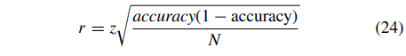
Accuracy is also stated as the sum of True Positive (TP) and True Negative (TN) to the sum of True Positive (TP), True Negative (TN), False Positive (FP) and False Negative (FN) using equation (25), as shown at the bottom of the page.

D.SENSITIVITY
Sensitivity and specificity are the important benchmark metric for evaluation of classification and thus sensitivity states True Positive (TP) to the sum of True Positive (TP) and False Negative (FN). Hence, it is given by equation (26)
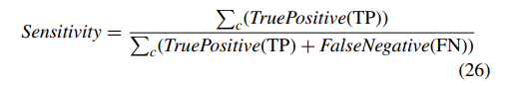
E.SPECIFICITY
Specificity is defined as the True Positive (TP) to the sum of True Positive (TP) and False Positive (FP). Calculated using equation (27),
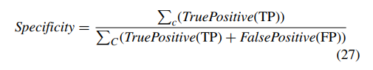
G.RECALL
Recall is measured as the summation of all class True Positive (TP) to the summation of class True Positive (TP)
and False Negative (FN), it is stated by the equation (17)
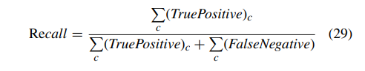
H.F1-SCORE
F1-score is used to measure the balance between the precision and recall. Furthermore, it is stated as the twice the product of precision and recall to the sum of product and sensitivity. Equation (30) states the precision calculation
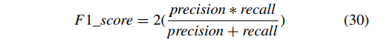
I CONFUSION MATRIX
Confusion matrix provides the model's overall performance, and the output is presented as a matrix. The confusion matrix in Figure 3 makes it evident that a normal person is 3430; these are the individuals who are unaffected by COVID-19. Of the individuals, 20 have a probable COVID-19 infection, 12 may have COVID-19, and 443 have a proven COVID-19 infection.
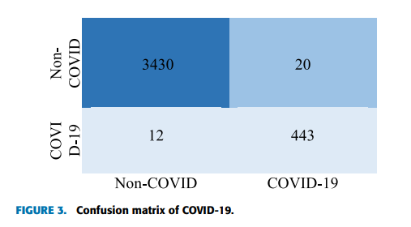
K.EXPECTED OUTCOMES
The tool is developed based on the GDCNN model which is very helpful for physicians and act confident in the treatment of a COVID-19 affected patient, while they are waiting for the second opinion confirmation with the radiologist. Furthermore, it provides a measurable score to consider and to use in research studies.

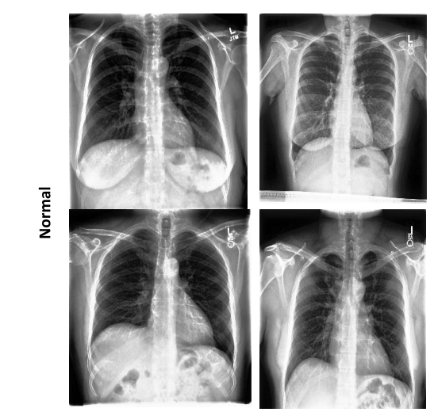

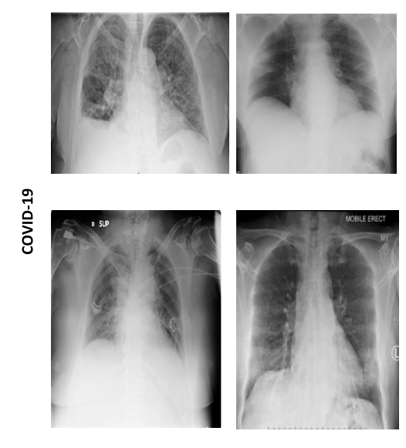

RESULTS/ANALYSIS
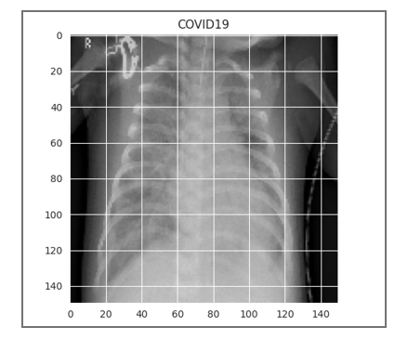
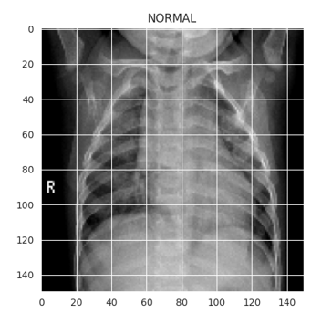
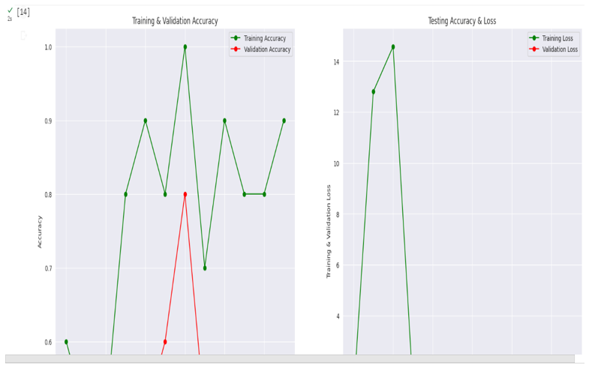

CONCLUSION
Due to the rapid transmission of COVID-19 and the exponential rise in cases, a pandemic is spreading throughout the world. It is imperative that disorders be diagnosed early in order to treat COVID-19 more quickly and affordably. A deep learning technique is applied in the forementioned scenario to predict COVID-19 using samples of CXR images. In the real world, many people do not contract pneumonia, while just a small number have been impacted. As a result, there is an imbalance in the likelihood of pneumonia between the afflicted individual and a healthy individual. Using CXR image data, the GDCNNN approach is proposed in this study to categorize COVID-19 and normal individuals. The publicly accessible library contains over 5000 image samples, including views of healthy lungs, images of pneumonia, and images of various pneumonia-related illnesses. It is possible to achieve the suggested strategy with an F1-score of 0.96337, Val accuracy of 0.99 (99.0%), loss of 0.32, and val_loss of 0.05. In addition, a comparative analysis is conducted between the proposed model and other current models, including resenet18, resenet50, SqueezeNet, Densenet-121, and VGG16, in order to assess its performance. The analysis table makes it evident that the suggested approach performs better than the current model. The primary goals of the study are to increase patient assistance in the early stages of treatment and improve the identification rate for COVID-19 prediction at the earlier stage of diagnosis. This model can be used by the company to make earlier predictions. The GDCNN tool, COVID-19, is hosted in a cloud computing environment. This instrument can help the medical system diagnose problems early. We intend to use this technique in the future to improve the accuracy of hierarchical categorization on a large-scale database.

REFERENCES
- Shreyas Setlur Arun , Ganesh Neelakanta Iyer ,“On the Analysis of COVID19 - Novel Corona Viral Disease Pandemic Spread Data Using Neural networks Techniques”, Proceedings of the International Conference on Intelligent Computing and Control Systems (ICICCS 2020) IEEE Xplore Part Number:CFP20K74-ART; ISBN: 978-1-7281-4876-2
- Mazin Abed Mohammed;Karrar Hameed Abdulkareem;Alaa S. Al-Waisy; Salama A. Mostafa;Shumoos Al-Fahdawi;Abdullah BAZ “Benchmarking Methodology for Selection of Optimal COVID-19 Diagnostic Model Based on Entropy and TOPSIS Methods”, IEEE ACCESS.2020.2995597.
- “Survival Analysis of COVID-19 Patients With Symptoms Information by Neural networks Algorithms”, IEEE Access, date of publication June 13, 2022, date of current version June 16, 2022. Digital Object Identifier 10.1109/ACCESS.2022.3182350.
[4] Diagnosis of covid-19 and its clinical spectrum dataset.
url=https://kaggle.com/einsteindata4u/covid19.
[5] WHO Director-General’s remarks at the media briefing on 2019-nCoV on 11 February 2020. Library Catalog: www. who.int.
[6] WHO EMRO | Questions and answers | COVID-19 | Health topics.
[7] Support Vector Machine Neural networks algorithm with example and code, January 2019. Library Catalog: www.cod ershood.info Section: Neural networks.
[8] Ali Al-Hazmi. Challenges presented by MERS corona virus, and SARS corona virus to global health. Saudi journal of biological sciences, 23(4):507–511, 2016. Publisher: Elsevier.
[9] Sina F Ardabili, Amir Mosavi, Pedram Ghamisi, Filip Ferdinand, Annamaria R Varkonyi-Koczy, Uwe Reuter, Timon Rabczuk, and Peter M Atkinson. Covid-19 outbreak prediction with neural networks. Available at SSRN 3580188, 2020.
[10] Hiba Asri, Hajar Mousannif, Hassan Al Moatassime, and Thomas Noel. Using neural networks algorithms for breast cancer risk prediction and diagnosis. Procedia Computer Science, 83:1064–1069, 2016.
[11] Taiwo Oladipupo Ayodele. Types of neural networks algorithms. New advances in neural networks, pages 19–48, 2010.
[12] Taiwo Oladipupo Ayodele. Types of neural networks algorithms. New advances in neural networks, pages 19–48, 2010. Publisher: InTech.
[13] David W Bates, Suchi Saria, Lucila Ohno-Machado, Anand Shah, and Gabriel Escobar. Big data in health care: using analytics to identify and manage highrisk and high-cost patients. Health Affairs, 33(7):1123–1131, 2014..
[14] Hetal Bhavsar and Amit Ganatra. A comparative study of training algorithms for supervised neural networks. International Journal of Soft Computing and Engineering (IJSCE), 2(4):2231–2307, 2012.
[15] Rich Caruana and Alexandru Niculescu-Mizil. An empirical comparison of supervised learning algorithms. In Proceedings of the 23rd international conference on Neural networks, pages 161–168, 2006.
[16] Nanshan Chen, Min Zhou, Xuan Dong, Jieming Qu, Fengyun Gong, Yang Han, Yang Qiu, Jingli Wang, Ying Liu, Yuan Wei, et al. Epidemiological and clinical characteristics of 99 cases of 2019 novel coronavirus pneumonia in wuhan, china: a descriptive study. The Lancet, 395(10223):507–513, 2020.
[17] Dursun Delen. Analysis of cancer data: a data mining approach. Expert Systems, 26(1):100–112, 2009.
[18] Manoj Durairaj and Veera Ranjani. Data mining applications in healthcare sector: a study. International journal of scientific & technology research, 2(10):29– 35, 2013.
[19] Ashok Kumar Dwivedi. Performance evaluation of different neural networks techniques for prediction of disease. Neural Computing and Applications, 29(10):685–693, 2018.

